Sr. IDP, Vortex, Institute of Chemical Technology
Energy-Efficient separation of Methanol and Water
Om Mihani, Sumit Kumar, Ananya Dhale

Abstract
Methanol is a crucial chemical for industries, produced in the order of 20 million Tonnes per Annum worldwide. The current production process requires water and methanol to be separated and achieve high-purity methanol. Distillation is the only method available to attain this purity. Our analysis aims to look for an alternative for distillation as it is very energy-intensive. The method proposed here for separation is Solid Phase extraction is a Temperature-Swing-Adsorption. Two fixed adsorber beds make up the process, one for adsorption and the other for desorption. In desorption mode at high temperatures, releasing the water that has been absorbed.

PROBLEM STATEMENT AND OBJECTIVE
Distillation is a fast and straightforward process. The basis for separation is the difference in liquid boiling points. The core of distillation is selective evaporation and condensation of particular components. We intend to solely evaporate and condense one component from the mixture. We must permit numerous evaporation and condensation cycles to achieve this goal. With time, the most volatile component eventually gains more enrichment in the vapor phase. The final condensate contains a liquid enhanced in the more volatile component after enough evaporation and condensation cycles.
However, it has its own limitations. One such serious rule is the components to be separated must have their boiling points far enough apart. If the difference is narrow, the process would contain too many stages, which is impractical. The method also fails to separate azeotropic mixtures. Azeotrope is a mixture where the vapor composition is the same as the composition of the liquid. Azeotropes are not even separated by fractional distillation, a specialized kind of distillation. Among all the problems, the most significant disadvantage of this process is its energy consumption. It consumes around 40% of the total energy used in the chemical and petroleum refining industries. A substantial amount of heat is required in the reboiler and rejects similar amounts of heat from the condenser but at a lower temperature, limiting the potential for heat recovery. Energy saving has become an essential factor for chemical and petrochemical processing plants. The high energy costs, economic conditions, and market fluctuations are forcing each company to take action to keep operating costs at the lowest possible level. Therefore, a different approach is to be brought depending on the process requirements and keeping the goal of minimum energy consumption in mind.

INTRODUCTION TO SOLID PHASE EXTRACTION
Solid phase adsorption is when contaminants or target molecules are separated from a liquid or gaseous mixture by binding to a solid surface. This process is widely used in industrial, environmental, and medical applications to purify, separate, and analyse substances. The solid surface, often in the form of a bead or a membrane, acts as an adsorbent and selectively binds the target molecules based on physical and chemical interactions. The adsorption process is based on the interaction between the target molecules and the surface of the solid adsorbent. This interaction can be either physical, such as van der Waals forces or hydrogen bonding, or chemical, such as ionic or covalent bonding. Solid phase adsorption is widely used in various fields, such as environmental monitoring, water purification, pharmaceuticals, the food and beverage industry, and biotechnology. For example, it removes heavy metals from water, purifies proteins and nucleic acids, and isolates target cells for further analysis.

TECHNICAL ANALYSIS
We have proposed to use a Temperature Swing Adsorption with Heat integration. We chose this method over others because of the following reasons:
1) Distillation: Highly energy-intensive
2) Liquid-Liquid extraction: Extra distillation step at later stages
3) Zeolites: Huge pressure difference needed
In solid phase extraction, we have chosen sorbent as Silica as it has preferential absorptivity for water in MeOH-H₂O system. We have used a Freundlich isotherm to approximate these numbers.
We did not do a complete analysis for a packed bed, but considered packed bed as combination of multiple mixed contactors, like a tank in series model. The code for this analysis is attached below. Observe that as we move towards infinite tanks, the amount of sorbent required reduces. This reduces capital cost.
Let’s discuss the working of model in short. One of the columns is always in desorption mode (High Temperature) and the other one in Adsorption mode (Low temperature). When these columns become desaturated and saturated respectively, the roles (Desorption/adsorption) are switched. This gives a swing like behaviour to system driven by temperature, hence, called temperature swing. Moreover, using the heat and the chill of the exiting water and methanol stream respectively saves us on operating costs as well.
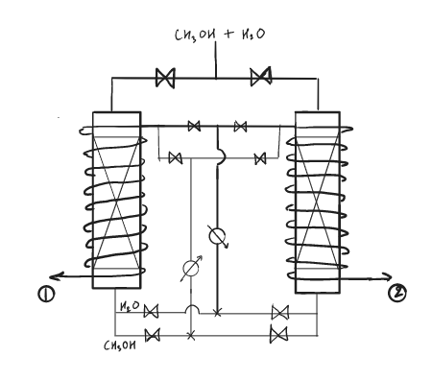
Fig: Heat integration in proposed temperature-swing adsorption.
Stream 1 and 2 are continuous contactor.

RESULTS
The amount of sorbent obtained for no. Of absorber beds respectively is as follows:
Single stage = 23227.0077
Double stage = 4219.2507
Quadruple stage = 2960.4043
As the number of ‘fixed bed’ stages increases, the amount of sorbent required decreases. This, as stated earlier can be modelled as ‘Tanks in Series’.

DISCUSSION
Silica gel is sold as a 25 kg drum at the rate of Rs 200/kg. For the ‘quadruple stage’, the cost of sorbent required would be = 200 × 2960.4043 = Rs 592080.86 = 5.92 Lakhs. Around 119 drums of silica would be needed, which is a less quantity.
Steam at 3.5 kg pressure has an enthalpy of condensation = 2144.4 KJ/kg, so the required steam flow rate = 43.22 (Reboiler Duty)/2144.4 = 0.02 kg/s = 72 kg/hr.
Operating cost would be (rate of steam required) × (cost of steam per kg) = 72 × 3 = 216 Rs/hr.
But in solid adsorption we need not heat the feed stream for adsorption so mainly capex is coming in picture

CONCLUSION
The operating cost is less in Solid Phase adsorption using silica for removing water from methanol as compared to distillation. So, we can claim this process is a better alternative.
REFERNCES

APPENDIX

